Computer Organization & Architecture

15B11CI313

**Tutorial-7**

Top of Form

**Top of Form**

1. **A CPU has only three instructions *I*1, *I*Bottom of Form 2 and *I*3, which use the following signals in time steps *T*1−*T*5**

:

*I*1: *T*1: Ain, Bout, Cin   
          *T*2 : PCout, Bin   
          *T*3 : Zout, Ain   
          *T*4 : Bin, Cout   
          *T*5: End

*I*2: *T*1: Cin, Bout, Din   
        *T*2 : Aout, Bin   
        *T*3 : Zout, Ain   
        *T*4 : Bin, Cout   
        *T*5: End

*I*3: *T*1: Din, Aout   
      *T*2 : Ain, Bout   
        *T*3 : Zout, Ain   
        *T*4 : Dout, Ain   
        *T*5: End

**Write logic functions that will generate the hardwired control for the signal Ain ?**

1. **A hardwired CPU uses 10 control signals S1 to S10, in various time steps T1 to T5, to implement 4 instructions I1 to I4 as shown below:** 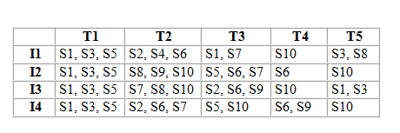

**Which of the following pairs of expressions represent the circuit for generating control signals S5 and S10 respectively? ((Ij+Ik)Tn indicates that the control signal should be generated in time step Tn if the instruction being executed is Ij or lk)**

1. **n instruction set of a processor has 125 signals which can be divided into 5 groups of mutually exclusive signals as follows:**

**Group 1 : 20 signals, Group 2 : 70 signals, Group 3 : 2 signals, Group 4 : 10 signals, Group 5 : 23 signals.**

**How many bits of the control words can be saved by using vertical microprogramming over horizontal microprogramming?**

|  |  |
| --- | --- |
|  |  |

1. **Consider a CPU where all the instructions require 7 clock cycles to complete execution. There are 140 instructions in the instruction set. It is found that 125 control signals are needed to be generated by the control unit. While designing the horizontal microprogrammed control unit, single address field format is used for branch control logic. What is the minimum size of the control word and control address register?**
2. **Consider a Single-Bus Basic Computer. Write Boolean function for various control signal.**

